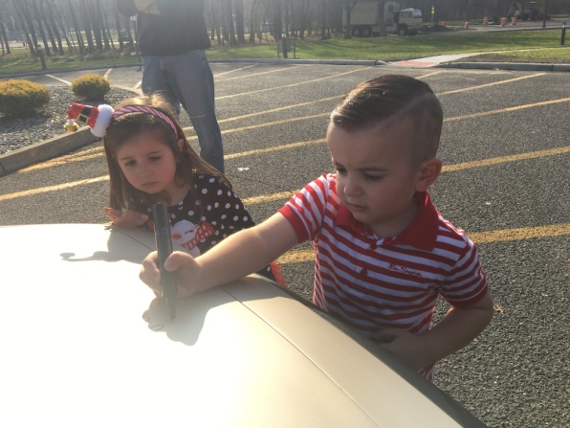
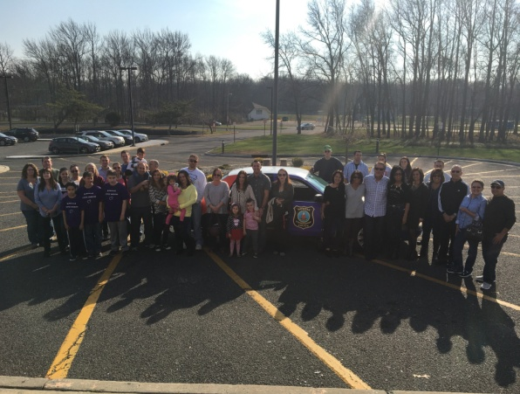

No Shave November Fundraiser-Grow the “Stache”
The Howell Township Police Department is again participating in “No Shave November” fundraising. Chief Andrew Kudrick has suspended normal grooming standards allowing officers to grow facial hair during the month of November as a method of raising awareness for various cancers and encouraging people to donate. Approximately 20 officers are participating this year in raising money and growing their “stache”.
We have again teamed up with the CentraState Healthcare Foundation at CentraState Medical Center in Freehold to raise funds for the tremendous service they provide to patients with cancer. Anyone donating $25 or more will be invited to sign our Cancer Fighting Police Car. See attached photos.
From our Crowdrise page:
Please donate to help the CentraState Healthcare Foundation fulfill the needs of their patients. The community based cancer care provided by CentraState provides prevention and treatment for our friends, families and neighbors right here in our local communities. Let's help them help others by growing their "stache" (get it-mustache/stash of money...never mind).
https://www.crowdrise.com/no-shave-november1/fundraiser/christianantunez
Visit their site at https://www.centrastate.com/cancer-center

